13.67: a) The quantity 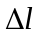 is the amount that the origin of coordinates has been moved from the unstretched length of the spring, so the spring is stretched a distance 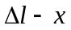 (see Fig. (13.16 ( c ))) and the elastic potential energy is 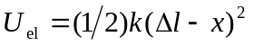.

b) 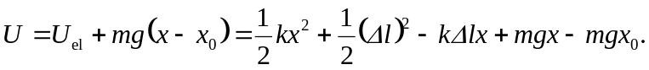
Since 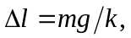 the two terms proportional to x cancel, and

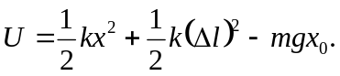

c) An additive constant to the mechanical energy does not change the dependence of the force on 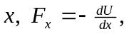 and so the relations expressing Newton’s laws and the resulting equations of motion are unchanged.

